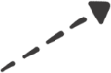

**Dongle Supplier**

**IT Department**

**2SAS  
Two Step Authentication Solution**

**MIND MAP**

**DIAGRAM TEMPLATE**

**Insert Text**

**Here**

**Insert Text**

**Here**

**Insert Text**

**Here**

**ECU**

**Insert Text**

**Here**

**Insert Text**

**Here**

**Insert Text**

**Here**

**Resources**

**Scope**

**Pitch**

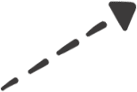

**STAKEHOLDERS**

**SCOPE**

**RESOURCES**

**TIMELINE**

